 Name: Gokul Nath S

E-mail: 12345.gokulnath.s@gmail.com

Lab - Research IT and Networking Job Opportunities

# Objectives

* Research Job Opportunities

# Background / Scenario

Jobs in Information Technology (IT) and computer networking continue to grow. Most employers require some form of industry standard certification, degree, or other qualifications from their potential employees, especially those with limited experience. The Cisco CCNA certification is a known and established entry-level networking certification that is respected in the industry. There are additional levels and kinds of Cisco certifications that one can attain, and each certification may enhance employment opportunities as well as salary range.

In this lab, you will complete targeted job searching on the web to find what types of IT and computer networking jobs are available; what kinds of skills and certifications you will need; and the salary ranges associated with the various job titles.

# Required Resources

* Device with Internet access

# Instructions

You will use a web browser to visit the popular job listing websites, such as monster.com and salary.com.

# Step 1: Open a web browser and go to a job listing website.

In the URL address bar type [http://monster.com](http://monster.com/) and press Enter.

**Note**: For job listings outside of the U.S., use the following link to search for your country: <http://www.monster.com/geo/siteselection/>

# Step 2: Search for networking related jobs.

1. Type the word ***Network Administrator*** in the **Keyword or Title** box. Click **Find Jobs** to continue.



1. Notice the search results. Now, focus your search by adding terms to the search for Network Administrator. Try terms like Cisco CCNA, CCNP, CCNA Security, CCNA Voice, etc.

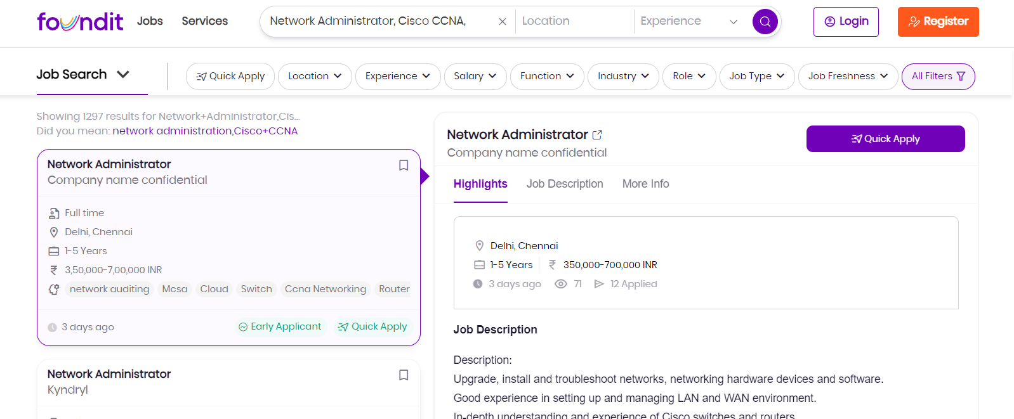

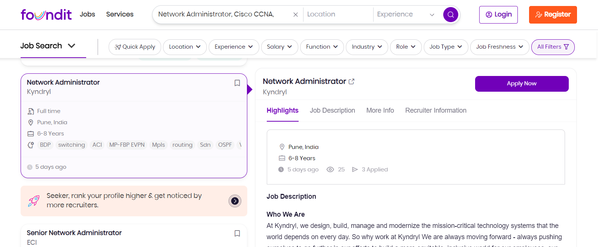

1. Now try refining your search by adding different geographical locations. Did you find jobs in the locations you entered?

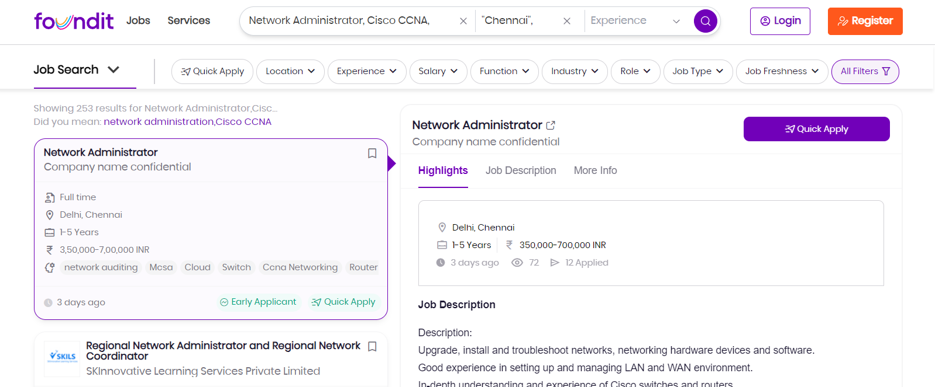

1. Try searching a different website. Go to [http://www.salary.com](http://www.salary.com/) and click the Job Search menu bar button. **Note**: For salary listings outside of the U.S., use the following link to search for your country: <http://www.payscale.com/rccountries.aspx>



1. Add a search term like ***Information Technology*** to the J**ob title or Keyword** field box and click **Get my salary estimate**.



1. Note the large number of matching search results. Select a job title that interests you. Click **SHOW MY SALARY ESTIMATE RESULTS**.



1. Spend time searching for jobs and looking through the search results. Take note of what skills are required for different job titles and the range of starting salaries.

**Lab - Research IT and Networking Job Opportunities**

# Reflection Questions

Answer the following questions based on your research findings.

1. What job titles did you search for?

**Network Administrator(CCNA) and Information Technology**

1. What skills or certifications were required?

**A lot of different certifications like (CCNA) and college education was required for various things, as well as experience, passion, commitment, teamwork skills, Networking knowledge, etc.**

1. Did you find any jobs that you previously did not know existed? If so, what were they?

**The ones I saw I knew about already, because my father and mother’s fiancee work in the computer field as a senior software engineer and IT respectively.**

1. Did you find any jobs that you are interested in? If so, which ones and what skills or certifications do they require?

**I saw a job opening for Regional Network Administrator and Regional Network Coordinator. The love of solving problems is important. The job requires network troubleshooting with LAN/WAN/WLAN/Firewall. Strong network design in new environment. 5 years working experience in Manufacturing & Office environment. 5 years+ working experience on network design for a new site. 5 years+ working experience on network troubleshooting with LAN/WAN/WLAN/Firewall. Experience with ITIL-Processes (Incident, Problem-, Change and Configuration Management).**

**FUNCTION-Manufacturing/Engineering/R&D**